UNISYS

City of Philadelphia 311

Global InformationRequest Standards

**Copyright © 2015 Unisys Corporation**

**All rights reserved**

Version 1.0

Created 14 March 2014

**Revision History**

|  |  |  |  |
| --- | --- | --- | --- |
| Version | Date | Author | Summary of Changes |
| 1.0 | 3/14/14 | Maureen O’Neill | Initial draft. |
| 1.1 | 8/21/14 | Jim Robb | Final document |
|  |  |  |  |
|  |  |  |  |
|  |  |  |  |
|  |  |  |  |
|  |  |  |  |

Contents

Document Overview 3

Standard High-Level Steps for Creating an Information Request from a KB Article 3

Standard High-Level Steps for Creating an Information Request when a KB Article does NOT Exist 6

Standard Case Fields Contained in the Standard Page Layout 9

Department Details Section 9

Case Information Section 12

Description Information Section 14

Resolution Information Section 15

Web Information Section 16

System Information Section 17

Standard Related Lists Contained in the Standard Page Layout 17

Articles 17

Related Cases 17

Open Activities 17

Activity History 17

Case Comments 17

Case History 17

Attachments 17

Standard Flow 18

Standard Support Process 18

Standard Profiles 18

Standard Case Escalation Rules 19

Standard Case Assignment Rule 19

Standard Case Validation Rules 19

Standard Case Workflow Rules 20

Standard Case Triggers 20

Standard Contact Triggers 20

# Document Overview

The purpose of this document is to define the standards being used to record and resolve all information requests received by the City of Philadelphia. An **Information Request** is a Case in Salesforce that is created and typically immediately resolved by the agent taking the call through a Knowledgebase **Article**. In the rare situation where the caller’s request for information cannot be answered by a Knowledgebase Article, the Case will remain open for the 311 team to research and resolve.

# Standard High-Level Steps for Creating an Information Request from a KB Article

The following “standard” high-level steps will be used to process a typical information requests that can be resolved by a Knowledgebase **Article**:

1. Constituent requests information
2. The agent enters keywords for the type of information being requested into the Global Search box and clicks the **Search** button.
3. Records that contain the content of the search parameter criteria are returned in a separate tab. Record Results are displayed by object type, such as **Cases**, Knowledgebase **Articles** and so on.   
   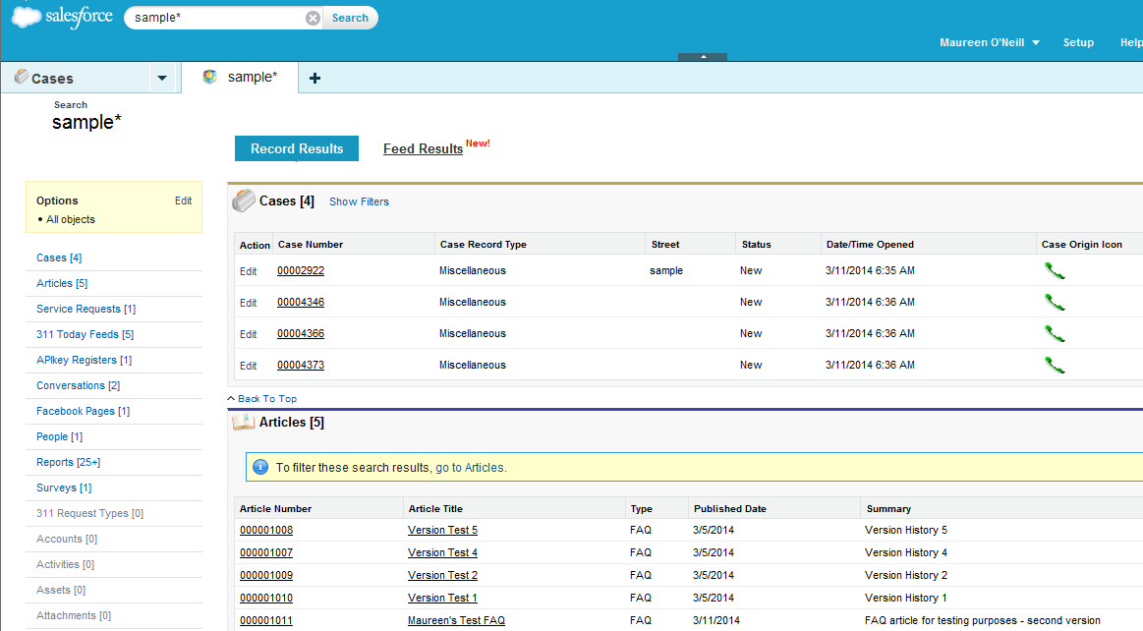
4. The Agent selects the **Article Title** link for the article record that pertains to the caller’s information request.
5. The system displays the article record selected by the agent.  
   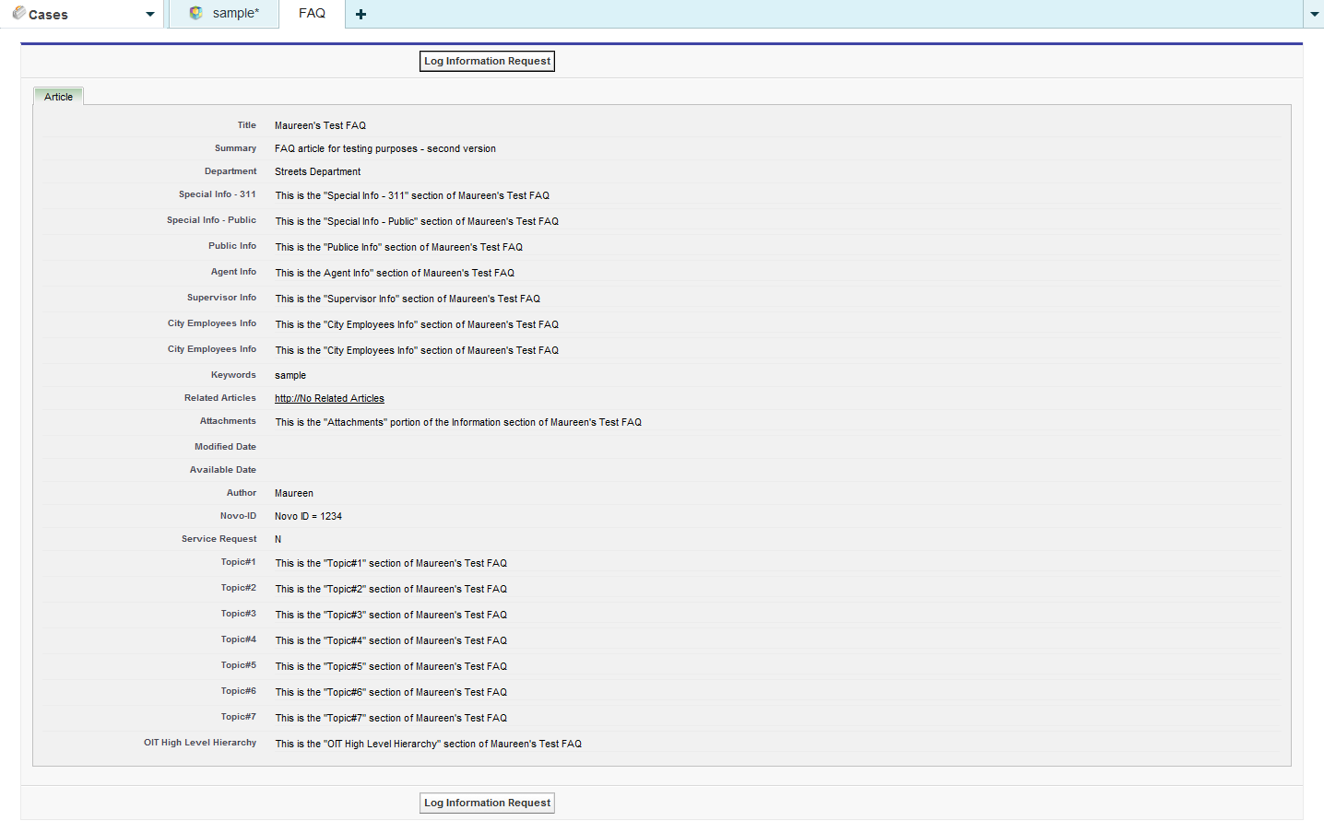
6. The agent reviews the data contained in the **Article** tab for the selected article and clicks the **Log Information Request** button if the data answers the caller’s request for information
7. The system:
   1. Creates a case with *Department* = <the Department from the KB article selected by the agent>, *Case Record Type* = Information Request, *Case Origin* = Phone, *Status* = New, *Priority* = 5, *Subject* = <the title of KB article selected by the agent> and associates the article selected by the agent to the case
   2. Executes the Case Assignment Rule, which sets the *Case Owner* = 311 Contact Center
   3. Display a screen that contains the **Case Edit** core **Page Layout** form in the center panel, a **Flow** script in the left sidebar, and **Suggested Articles** in the right sidebar.  
        
      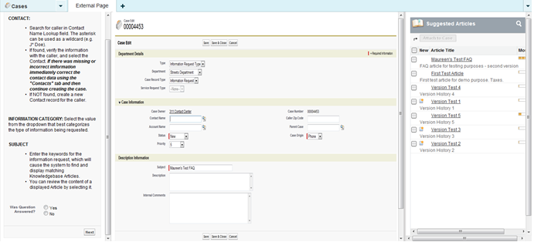
8. The **Case Edit** core **Page Layout** contains the form that shows the case data automatically created by the system based on the article selected by the agent to resolve the caller’s request for information (see Step #5) and allows the agent to enter supplemental data, such as *Contact Name*, *Caller Zip Code*, *Description*, and *Internal Comments*.
9. The **Flow** in the left sidebar contains information associated with the Page Layout to assist the agent in completing the form and providing additional information to the caller.
10. **Suggested Articles** provides links to Knowledgebase articles corresponding to the data supplied in the *Subject* field for the Information Request. The system has already associated the Information Request case to the article selected by the agent to resolve the caller’s request for information (see Step #5).
11. The agent should:
    1. Populate the *Contact Name* field by searching for or creating a Contact record using the *Contact* lookup icon or ask for and populate the *Caller Zip Code* field if the caller is not willing to provide their contact data.
12. If a Contact record was associated to the case the system will automatically populate the *Caller Zip Code* field with the zip code data from the Contact record.
13. If no zip code is obtained, then “Declined” should be entered into the *Caller Zip Code* field.
    1. Populate the *Description* field to document the caller’s request and how it was resolved
    2. Populate the *Internal Comments* field to create a Comments record associated to the case if one is needed
    3. Select the **Save and Close** button.
14. The system:
    1. Updates Status = Closed and Case Reason = Question Answered
    2. Displays the Case Detail page to the agent.   
         
       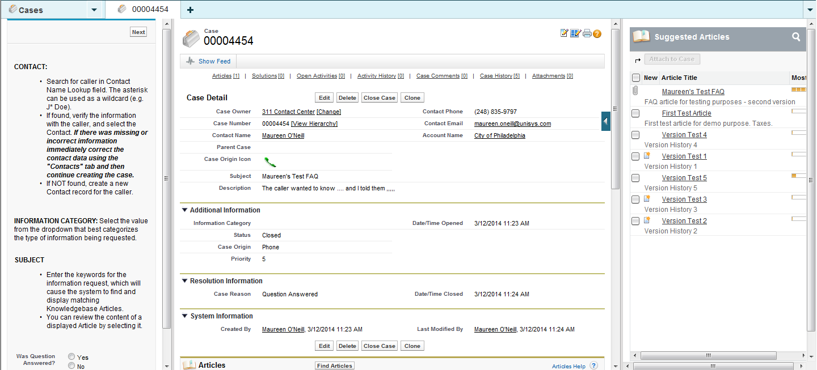
15. The agent may elect to send the caller an email documenting the answer to the caller’s question using the **Send an Email** button in the **Activity History** related list section of the case.   
    
    1. The Article can be provided as an attachment by selecting the **Select Template** button and then choosing the ‘*SUPPORT: Case Response with Article’ email template   
       

# Standard High-Level Steps for Creating an Information Request when a KB Article does NOT Exist

The following “standard” high-level steps will be used to process an information requests that cannot be resolved by a Knowledgebase **Article**.

1. Constituent requests information
2. The agent enters keywords for the type of information being requested into the Global Search box and clicks the Search button. 
3. Records that contain the content of the search parameter criteria are returned in a separate tab. Record Results are displayed by object type, such as Cases, Knowledgebase Articles and so on.   
   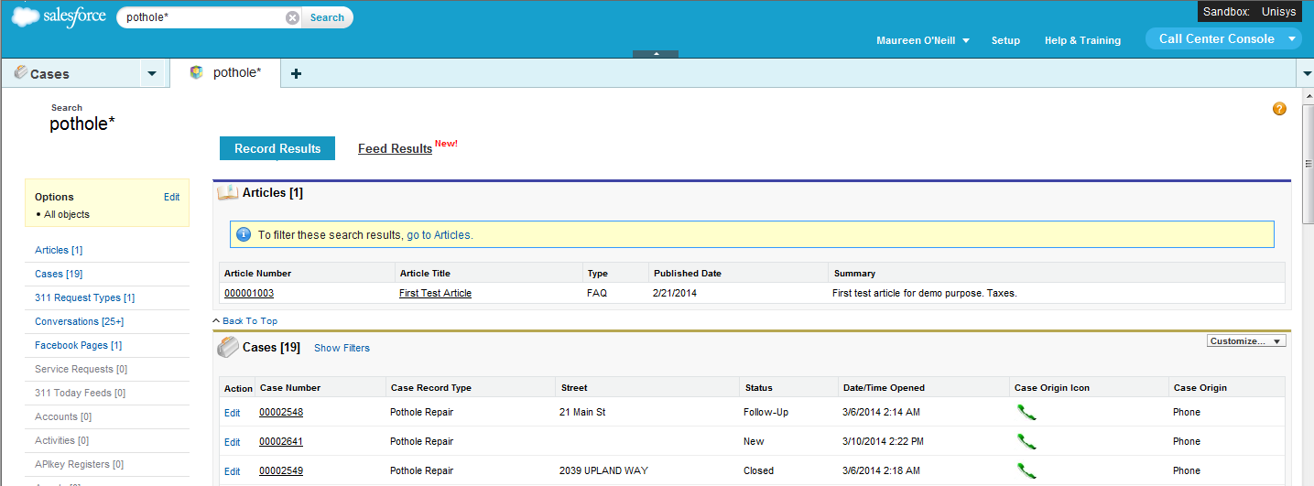
4. If no records appear in the Articles section of the search results OR the articles that do appear in the Articles section of the search results do not answer the caller’s information request, the agent:
   1. Closes the search results tab
   2. Select the **Information Request** button on the **Cases** list view page  
      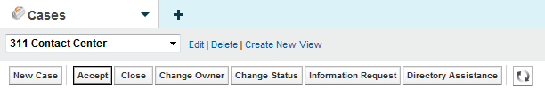
5. The system:
   1. Displays a screen that contains the **New Case** core **Page Layout** form in the center panel, a **Flow** script in the left sidebar, and **Suggested Articles** in the right sidebar.  
        
      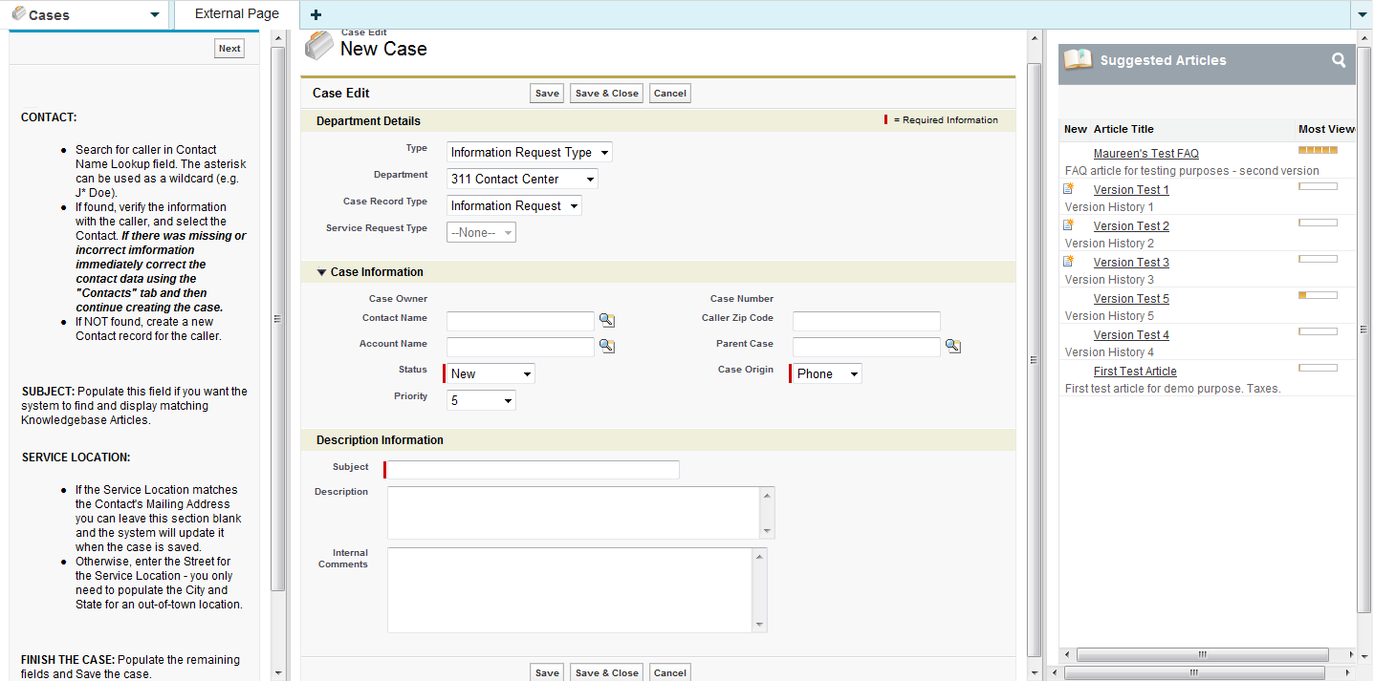
6. The **New Case** core **Page Layout** contains the form the agent needs to complete to create a case to record the caller’s request for information.
7. The **Flow** in the left sidebar contains information associated with the Page Layout to assist the agent in completing the form and providing additional information to the caller.
8. **Suggested Articles** provides links to Knowledgebase articles corresponding to the data supplied in the *Subject* field for the Information Request. This section assumes no articles exist that resolves the caller’s information request.
9. The agent should:
   1. Leave the default values in the *Type*, *Department*,and *Case Record Type* fields (e.g. Information Request Type, 311 Contact Center, and Information Request respectively)
   2. Populate the *Contact Name* field by searching for or creating a Contact record using the *Contact* lookup icon – the case must be associated to a Contact in order to phone or email the caller back with the resolution to their unanswered information request.
10. The system will automatically populate the *Caller Zip Code* field with the zip code data from the Contact record.
    1. Populate the *Subject* field with the keywords that summarize the caller’s request
    2. Populate the *Description* field to document the caller’s request and indicate that no KB Articles could be found to resolve the request.
    3. Populate the *Internal Comments* field to create a Comments record associated to the case if one is needed
    4. Select the **Save** button.
11. The system:
    1. Auto-generates the next sequential *Case Number* and creates the “open” case
    2. Associates the ***Contact*** record and related ***Account*** record to the case, if applicable
    3. Executes the Case Assignment Rule, which sets the *Case Owner* = 311 Contact Center
    4. Creates associated ***Case Comment*** record if “Internal Comments” field was populated.
    5. Sends an email to contact indicating a new case has been created for their unanswered information request if the “Send Notification Email to Contact” checkbox is selected.
12. The standard “Case Creation” template will be used for the email.
    1. Displays the Case Detail page to the agent.   
       
13. A **Queue Member** responsible for resolving open cases with Case Owner = 311 Contact Center:
    1. Changes the **Status** field from ‘New’ to ‘In-Progress’ on the case via the **Edit** case button and saves the change
    2. Researches the caller’s question
    3. Creates a new KB Article and manually attaches it to the case OR updates the *Description* field to document the answer the caller’s question
    4. Supplies the Contact with the answer to their question
14. The Queue Member may elect to send the caller an email documenting the answer to the caller’s question using the **Send an Email** button in the **Activity History** related list section of the case.   
    
    1. The Article can be provided as an attachment by selecting the **Select Template** button and then choosing the ‘*SUPPORT: Case Response with Article’ email template   
       
    2. Selects the **Close Case** button on the **Case Details** page and completes the **Close Case** page displayed by the system – the previously “open” Information Request is now “closed”

# Standard Case Fields Contained in the Standard Page Layout

The following describes the standard Salesforce fields and custom fields created for the City that will be contained in the Page Layout for Information Requests (fields shown in the top-down order they appear):

## Department Details Section

| **Field Label** | **Field Type** | **Custom** | **R e q u**  **I**  **r**  **e**  **d** | **R e a d**  **O n l y** | **Validation**  **Rule #** | **H i s t o r y** | **Comments** |
| --- | --- | --- | --- | --- | --- | --- | --- |
| Type | Picklist  **Values:** Service Request Type, Information Request Type, Directory Services  **Default:** | N | Y | N | None | Y | The list of valid values will be defined for each case *Record Type*.   * All picklist values should be available for all case *Record Type*   Field is initially auto-populated based on the default value for the case *Record Type* being created.  If the Actor manually changes the *Type* field to ‘Information Request Type’, the system will set the *Case Record Type* field to ‘Information Request’ and the *Department* field to the default value for the case *Record Type* = ‘Information Request’.  If the Actor manually changes the *Type* field to ‘Directory Assistance’, the system will set the *Case Record Type* field to ‘Directory Assistance’ and the *Department* field to the default value for the case *Record Type* = ‘Directory Assistance’.  If the Actor manually changes the *Type* field to ‘Service Request Type’, the system will set the *Case Record Type* field to ‘Miscellaneous’ and the *Department* field to the default value for the case *Record Type* = ‘Miscellaneous’. |
| Department | Picklist  **Values:** License & Inspections, Fire Department, Neighborhood Services, Police Department, Streets Department, Health Department, Revenue / Water Revenue, Boards / Commissions, Government (State/Federal), 311 Services, *<more may be identified>*  **Default:** | Y | Y | N | None | N | The list of valid values will be defined for each *Record Type*.   * All picklist values should be available for case *Record Type* = Information Request, Directory Assistance, and Miscellaneous   This field is initially auto-populated based on the default value for the case *Record Type* being created with the following exception:   * If the case was initiated from an Aricle by selecting the **Log Information Request** button, the *Department* field will be set to the value in the *Department* field on the Article record.   The *Department* field will be automatically updated by the system if the *Type* field changes – see the Comments section for the *Type* field. |
| Case Record Type  *(not to be confused with the standard Salesforce case field with Field Name = Record Type and Label = Case Record Type)* | Dependant Picklist  (Controlling Field =Department)  **Values:** Abandoned Vehicle  Boarding Room House,  Building Dangerous,  Dangerous Sidewalk,  Daycare Residential or Commercial,  Illegal Dumping,  Information Request,  License Contractor,  No Heat (Residential),  Pothole Repair,  Rubbish Collection,  Street Light Outage,  Traffic Signal Emergency,  Park Conditions Safety and Maintenance,  Alley Light Outage,  Miscellaneous,  Graffiti,  Complaints against Fire or EMS, *<more may be identified>*  **Default:** |  |  |  |  |  | The list of valid values will be defined for each *Record Type* and will be further filtered by the *Department* controlling field.  Field is initially auto-populated based on the default value for the case *Record Type* being created.   * NOTE: The value in the *Case Record Type* field and the case *Record Type* field should always be the same.   The *Case Record Type* field will be automatically updated if the *Type* field changes – see the Comments section for the *Type* field.  If the value in the *Case Record Type* field is changed by the Actor or the system, the system will also change the *Record Type* field to the same value and change the Page Layout being displayed to the Page Layout associated with the new case *Record Type*.   * The content in the fields shared by the old and new Page Layout will be retained (e.g. Contact Name, Subject, Description, etc). |
| Service Request Type | Dependant Picklist  (Controlling Field =Case Record Type)  **Values:** Miscellaneous,  Service Not Needed,  Boarding Room House,  Building Dangerous,  Rubbish Collection,  License Contractor,  Daycare Residential or Commercial,  NoHeatResidential,  Pothole Repair,  Ditch Repair,  Cave-In Repair,  Graffiti,  Street Light Outage,  Illegal Dumping,  Vacant Lot Clean Up,  Sanitation Violation,  Abandoned Vehicle,  Building Construction,  Electrical Construction,  Recyclables Collection,  911 Call Transfer,  Traffic Signal Emergency,  Park Conditions Safety and Maintenance,  Alley Light Outage,  Information Request,  Street Light(Other),  Complaint for Fire, Department or EMS, *<more may be identified>*  **Default:** | Y | Y | Y | None | Y | The list of valid values will be defined for each *Record Type* and will be further filtered by the *Case Record Type* controlling field.  This field will be auto-populated based on the default value for the case *Record Type* being created if there is one.   * The default value will only be set when there is one and only one valid *Service Request Type* for the case *Record Type* being created.   If there is not a default value because the case *Record Type* has more than one valid *Service Request Type*, the system will populate this field based on the value entered by the agent for a specific field(s) on the case.   * Some case *Record Types* may include a *Service Request Type* = Service Not Needed that may be used by the system based on the value entered by the agent for a specific field(s). When this value is used the system will close the case with a *Case Reason* = Service Not Needed indicating that based on the data gathered the service was not needed or allowed.   The Actor should be prohibited from populating/changing the *Service Request Type* field. |

## Case Information Section

| **Field Label** | **Field Type** | **Custom** | **R e q u**  **I**  **r**  **e**  **d** | **R e a d**  **O n l y** | **Validation**  **Rule #** | **H i s t o r y** | **Comments** |
| --- | --- | --- | --- | --- | --- | --- | --- |
| Case Owner | Lookup(User,Queue) | N | N | N | None | Y | When a case is created this field is set to the User creating the case. Upon save, the Standard Case Assignment Rule is executed and this field is updated to a Queue based on the case’s Record Type and/or Service Request Type. Once the case is saved this field can be manually changed by a user. |
| Case Number | Auto Number | N | N | Y | None | N | The system automatically populates this field when a case is created. |
| Date/Time Opened | Date/Time | N | N | Y | None | N | System populated field of the date and time the case was created |
| Caller Zip Code | Lookup(Contact) | Y | Y | N | None | Y | This field will be populated by the Zip Code in the Contact record if one is associated with the case, otherwise the agent may populate it with a number from the caller. |
| Contact Name | Lookup(Contact) | N | N | N | None | Y | This field contains the Contact requesting the service. Ideally every case should have an associated contact. |
| Account Name | Lookup(Account) | N | N | N | None | N | This field contains the Account associated with the Contact record. |
| Parent Case | Lookup(Contact) | N | N | N | None | N | Two cases can be associated to each other via a parent/child relationship. This field identifies the “Parent” case. “Child” cases are displayed in the “Related Cases” Related List section for the “Parent” case. |
| Case Origin icon | Formula(Text) | Y | N | Y | None | N | Shows an image representing the value in the Case Origin field. The formula for this field is:  IMAGE(  CASE( Origin,  "Email", "https://<SalesforceOrg>.content.force.com/servlet/servlet.FileDownload?file=015K0000000238q",  "Phone",  "https://<SalesforceOrg>.content.force.com/servlet/servlet.FileDownload?file=015K0000000238R",  "Web",  "https://<SalesforceOrg>.content.force.com/servlet/servlet.FileDownload?file=015K000000023QL",  "/s.gif"),  "Origin Flag") |
| Contact Phone | Phone | N | N | Y | None | N | This display-only field is from the “Phone” field on the Contact record associated to the case. |
| Contact Email | Email | N | N | Y | None | N | This display-only field is from the “Email” field on the Contact record associated to the case. |
| Status | Picklist  **Values:** On Hold, Escalated, Closed, New, In-Progress  **Default** = New | N | Y | N | None | Y | This required field defines the status of the case.   * “New” is the default value when creating a case. * All values except “Closed” are available when creating or editing a case.   “Closed” is the only value that can be selected when the “Close Case” button is used. |
| Case Origin | Picklist  **Values:** Email, Phone, Web  **Default** = Phone | N | Y | N | None | Y | This optional field provides the in-depth description of the case. |
| Priority | Picklist  **Values:** 1,2,3,4,5,6,7,8,9  **Default** = 5 | N | N | N | None | N | This field allows a user to easily create a Comment while creating or editing a case. The data entered in this field will be used by the system to create a Comment record that will be displayed in the “Case Comments” Related List section of the case. |

## Description Information Section

| **Field Label** | **Field Type** | **Custom** | **R e q u**  **I**  **r**  **e**  **d** | **R e a d**  **O n l y** | **Validation**  **Rule #** | **H i s t o r y** | **Comments** |
| --- | --- | --- | --- | --- | --- | --- | --- |
| Subject | Text(255) | N | Y | Y | None | Y | This field will be auto-populated and read-only with the *Service Request Type* when creating a new SR Case.  This field will be auto-populated and read-only with the value from the article *Title* field if an article record used to create the new IR case  The system will find and display Knowledgebase Articles using the content in the “Subject” field. |
| Description | Long Text Area(32000) | N | N | N | None | Y | This field should be populated by the agent to provide the in-depth description of the case. The Flow may define specific information the Agent should supply in this field. |
| Internal Comments | Text Area(4000) | N | N | N | None | N | This field allows users to enter a Comment while creating or editing a case. Data entered in this field will be used by the system to create a Comment record that will be displayed in the “Case Comments” Related List section of the case. |

## Resolution Information Section

This section will only be displayed on the Case Detail page and the fields will only be populated if the case is “closed”.

| **Field Label** | **Field Type** | **Custom** | **R e q u**  **I**  **r**  **e**  **d** | **R e a d**  **O n l y** | **Validation**  **Rule #** | **H i s t o r y** | **Comments** |
| --- | --- | --- | --- | --- | --- | --- | --- |
| Close Reason | Formula (Text) | Y | N | Y | None | N | This field shows what a user entered in the Reason field when they closed the case. The formula for this field is:  TEXT(Reason) |
| Resolution Description | Formula (Text) | Y | N | Y | None | N | This field shows what a user entered in the Issue Resolution field when they closed the case. The formula for this field is: Issue_Resolution__c |
| Date/Time Closed | Date/Time | N | N | Y | None | N | System populated field of the date and time the case was closed |
| Age to Close in Business Hours | Formula(Number) | Y | N | Y |  | N | This field shows the number of Business Hours between when the case was opened and when it was closed. The formula for this field is:  Case_Age_In_Business_Hours__c  The Case Age in Business Hours field is populated by a trigger – see Standard Case Triggers. |

The following fields are NOT contained on the Standard Page Layout, but are needed to display the fields shown in the Resolution Information section:

| **Field Label** | **Field Type** | **Custom** | **R e q u**  **I**  **r**  **e**  **d** | **R e a d**  **O n l y** | **Validation**  **Rule #** | **H i s t o r y** | **Comments** |
| --- | --- | --- | --- | --- | --- | --- | --- |
| Case Age in Business Hours | Number(15,3) | Y | N | N | None | N | This field shows the number of Business Hours between when the case was opened and when it was closed. This field is populated by a trigger – see Standard Case Triggers. |
| Case Reason | Picklist  **Values:** Completed, Complied, Duplicate Request, Emergency Call, Invalid, Not Found, Question Answered  **Default** = None | N | Y | N | None | Y | This required field appears when a case is being closed. Users must select the appropriate reason for closing the case. |
| Issue Resolution | Text Area(255) | Y | N | N | None | Y | This optional field appears when a case is being closed. Users may enter the details on how the case was closed. |

## Web Information Section

This section will only appear for cases submitted via Twitter or Facebook, which are not part of the Unisys standard Salesforce configuration. This section must contain the following fields:

| **Field Label** | **Field Type** | **Custom** | **R e q u**  **I**  **r**  **e**  **d** | **R e a d**  **O n l y** | **Validation**  **Rule #** | **H i s t o r y** | **Comments** |
| --- | --- | --- | --- | --- | --- | --- | --- |
| Web Email | Email | N | N | Y | None | N |  |
| Web Name | Text(80) | N | N | Y | None | N |  |
| Web Company | Text(80) | N | N | Y | None | N |  |
| Web Phone | Text(40) | N | N | Y | None | N |  |

## System Information Section

| **Field Label** | **Field Type** | **Custom** | **R e q u**  **I**  **r**  **e**  **d** | **R e a d**  **O n l y** | **Validation**  **Rule #** | **H i s t o r y** | **Comments** |
| --- | --- | --- | --- | --- | --- | --- | --- |
| Created By | Lookup(User) | N | N | Y | None | N | User that created the case |
| Last Modified By | Lookup(User) | N | N | Y | None | N | Last User that modified the case |

# Standard Related Lists Contained in the Standard Page Layout

The following describes the “standard” ***Related Lists*** that will be contained in all Page Layouts associated with service request case Record Types (lists are shown in the order they appear):

## Articles

This related list displays all Knowledgebase Articles that have been associated to the case.

## Related Cases

When a case is being created or edited it can be designated as a “Child Case” by setting the “Parent Case” using the “Parent Case” lookup field. This related list displays all of the “Child Cases” for a “Parent Case”.

## Open Activities

This related list displays open tasks and open event (appointment, call, email, meeting, etc.) that have been associated to the case. A calendar can also be displayed showing scheduled events.

## Activity History

This related list displays all completed tasks, logged phone calls, saved interaction logs, expired events, outbound emails, and merged documents that have been associated to the case.

## Case Comments

This related list displays all the Comments that have been associated to the case.

## Case History

This related list displays all changes to any field on the case that had the “Track History” option set.

## Attachments

This related list displays all attachments that have been associated to the case.

# Standard Flow

The flow will be used to provide the agent with instructions to help complete the Information Request case they are creating. The purpose of this Flow is not to replace the material stored in the Knowledgebase, but provide the agent with enough information to complete the case. If the caller is requesting more specific information then is provided in the flow, the agent should refer to the Knowledgebase articles provided in the right sidebar. The flow for Information Requests is as follows:

* **Purpose**: To report a customer’s request for information that is answered using a KB Article or escalated to the 311 team to be researched and resolved when an Article could not be found.
* **Contact**: Populate the *Contact Name* field or the *Caller Zip Code* field if the caller is not willing to provide their contact data (Contact required if the question was not answered).
* **Description**: Describe caller’s question and how you answered it or next steps if not answered.
* **Question Answered**: *Save and Close* the case (sets Close Reason = Question Answered)
* **Question NOT Answered**: *Save* the case (case remains open for 311 team to research/resolve)
* send the caller an email documenting the answer to the caller’s question send the caller an email documenting the answer to the caller’s question
* **Advise the constituent**:

# Standard Support Process

Support processes use the ***Status*** field to identify a case within the support lifecycle. Most 311 Contact Centers create one ***Support Process*** that determines the picklist values available for the case ***Status*** field, with “New” set as the default value displayed when creating a new case. The following is the “standard” ***Support Process*** to be used with all case ***Record Types***:

* New
* In-Progress
* Escalated
* On hold
* Closed

# Standard Profiles

All Case Record Types will be made available to the following Profiles:

* 311 Agents, 311 Supervisors, Case Workers, and System Administrators

The “Miscellaneous” Case Record Type will be set up as the default for each of these profiles.

# Standard Case Escalation Rules

Escalation Rules allow you to define automated actions when cases with specific criteria are “open” after a specified period of time. They can help you identify when cases have fallen outside of an intended service level. When escalating a case, you can choose to automatically notify a user, reassign the case to another user or queue, or both.

The City has opted to manually escalate cases on an as needed basis instead of using automatic case escalation rules. This can be accomplished as follows:

* Select the “Change Status” button for the desired case(s) and update the “Status” to “Escalated”.
* Select the “Change Owner” button for the desired case(s) and select the appropriate “User” or “Queue” responsible for managing the escalated case(s).

There are no “standard” ***Case Escalation Rules*** at this time.

# Standard Case Assignment Rule

The standard assignment methodology is to assign each unique case *Record Type* and/or *Service Request Type* to a Queue, representing the group of users responsible for resolving/closing that type of case. Each case ***Record Type*** and/or ***Service Request Type*** must be addressed by one of the assignment “Rule Entries” that are executed sequentially based on the Order value. For departments that utilize a separate work order management system, the assignment queues will be used primarily as aggregators for reporting purposes.

* Rule Entry for Information Requests: Case Owner = 311 Contact Center if case Record Type = Information Request.
  + An assignment notification email will not be generated. The Contact Center will manage open cases for Case Owner = 311 Contact Center

# Standard Case Validation Rules

Validation Rules help improve data quality by preventing users from saving incorrect data. You can define one or more validation rules that consist of an error condition and corresponding error message. Validation rules are executed at record save time. If an error condition is met, the save is aborted and an error message displayed.

The following are the standard ***Case Validation Rules***for Information Requests:

|  |  |  |  |  |
| --- | --- | --- | --- | --- |
| **Rule #** | **Rule Name** | **Validation Rule** | **Error Message** | **Comments** |
| None |  |  |  |  |
|  |  |  |  |  |
|  |  |  |  |  |

# Standard Case Workflow Rules

Contact Centers operate more efficiently with standardized internal procedures and automated business processes. Many of the tasks you normally assign, the emails you regularly send, and other record updates are part of your organization's standard processes. Instead of doing this work manually, you can configure Workflow Rules to do it automatically.

Each workflow rule consists of:

* Criteria that cause the workflow rule to run.
* Immediate actions that execute when a record matches the criteria, such as sending an email or updating a field.
* Time-dependent actions that queue when a record matches the criteria, and execute according to time triggers.

The following are the standard “Case” Workflow Rules applicable for Information Requests:

| **Rule Name** | **Rule Description** | **Evaluation Criteria** | **Rule Criteria** | **Workflow Action** |
| --- | --- | --- | --- | --- |
| SLA | Combines SLA number and type into one field | Evaluate the rule when a record is created, and every time it’s edited | Case: Case Numbernot equal to null | Use the following formula to update Case: SLA ref: TEXT( SLA_Number__c ) & " " & SLA_Type__c |

# Standard Case Triggers

A Case trigger is Apex code that executes before or after specific Data Manipulation Language (DML) events occur, such as before a Case record is inserted into the database.

Unisys has developed the following “standard” ***Case Trigger***:

CalculateBusinessHoursAges: Calculates the total business hours between when a case was opened and when it was closed and then populates “Case Age in Business Hours” field, which is displayed in the “Age to Close in Business Hours” field shown within the “Resolution Information” section of the case.

# Standard Contact Triggers

A Contact trigger is Apex code that executes before or after specific Data Manipulation Language (DML) events occur, such as before a Contact record is inserted into the database.

Unisys has developed the following “standard” ***Contact Trigger***:

Account_Name_Update: When a new Contact is created during the case creation process, the system does not allow for an Account to be associated to the Contact, yet Account is a required field for a Contact. Whenever a new Contact is created without an Account, this trigger will associate the Account record with Name = “City of Philadelphia” to the Contact record.